INTERNSHIP PROJECT REPORT
AI-POWERED ENGINEERING INSIGHT ASSISTANT (AEIA)
An offline explainable desktop application for engineering data analysis, anomaly detection and report generation

CERTIFICATE
This is to certify that the internship project report titled “AI-Powered Engineering Insight Assistant (AEIA): An Offline Explainable Desktop System for Engineering Data Analysis” is a bonafide record of work carried out by the student under the supervision of the industry guide and internal guide during the internship period.
The work presented in this report has been carried out to the best of our knowledge and has not been submitted to any other university or institution for the award of any degree or diploma.

Industry Guide Signature | __________________________
Internal Guide Signature | __________________________
Head of Department | __________________________

DECLARATION
I hereby declare that the internship project report entitled “AI-Powered Engineering Insight Assistant (AEIA)” is my original work and has been prepared based on the work carried out during the internship period. The report has been written under the guidance of the industry guide and internal guide and has not been copied from any other source except where properly cited.
I also declare that the contents of this report are true to the best of my knowledge and that the project demonstrates the implementation and validation of an offline explainable engineering analysis tool for maintenance decision support.

Date | __________________________
Place | __________________________
Student Signature | __________________________

ACKNOWLEDGEMENT
I express my sincere gratitude to my project guide for providing valuable guidance, continuous encouragement and technical support throughout the completion of this internship project.
I am thankful to the Head of the Department, faculty members and the internship environment for providing the necessary facilities and an excellent learning opportunity.
I also extend my gratitude to the researchers, software communities and open-source contributors whose work in data analysis, machine learning, explainable AI, desktop application development and report generation helped shape this project.
Finally, I express my heartfelt gratitude to my family, friends and everyone who directly or indirectly supported me throughout the completion of this project.

ABSTRACT
The aviation and maintenance sectors increasingly require tools that can convert large volumes of operational data into actionable engineering insights. Traditional maintenance workflows often depend on manual review of logs and sensor data, which can be time-consuming, inconsistent and difficult to scale on low-end systems.
This internship project presents the design and development of the AI-Powered Engineering Insight Assistant (AEIA), an offline desktop application that supports engineering data analysis, anomaly detection, engineering-rule evaluation and report generation. The system is built around a deterministic pipeline so that every finding can be traced back to statistical evidence, detector output or rule logic.
The application uses Python with PyQt5 for the GUI, pandas and NumPy for data processing, scikit-learn for anomaly detection, Matplotlib for charts, ReportLab for PDF generation and SQLite for local history storage. A template-based natural language generation module converts structured findings into a plain-language executive summary suitable for engineering review.
The project was optimized for low-end, CPU-only, offline workstations and validated on multiple datasets to reduce false positives, improve responsiveness and support packaging as a standalone executable. The final result is a practical decision-support tool that helps engineers understand operational health quickly and confidently.
Keywords: Artificial Intelligence, Explainable AI, Predictive Maintenance, Engineering Decision Support, Offline Desktop Application, PyQt5, SQLite, Machine Learning.

TABLE OF CONTENTS
Certificate
Declaration
Acknowledgement
Abstract
Table of Contents
List of Figures
List of Tables
List of Abbreviations
Chapter 1 Introduction
1.1 Introduction
1.2 Motivation
1.3 Objective-Major
1.4 Present-Day Scenario and Relevance
Chapter 2 Background Theory and Literature Review
2.1 Background Theory
2.2 Literature Review
2.3 Summarized Outcome
Chapter 3 Objective & Methodology
3.1 Methodology
3.2 Component Specifications and Tools Used
Chapter 4 Result Analysis
4.1 Analysis Output and Observations
4.2 Performance and Validation Summary
Chapter 5 Conclusion and Future Scope
5.1 Work Conclusion
5.2 Future Scope of Work
References
Annexures

LIST OF FIGURES
Figure 1.1 AEIA System Workflow Diagram
Figure 2.1 Evidence Fusion and Explainability Overview
Figure 3.1 Overall Software Architecture of AEIA
Figure 3.2 AEIA Main User Interface
Figure 4.1 Analysis Dashboard Screenshot
Figure 4.2 Executive Summary and Findings Screenshot
Figure 4.3 Sample PDF Report Screenshot
Table A.1 - Complete System Architecture
Figure B.1 – History Page
Figure B.2 – Setting Page

LIST OF TABLES
Table 1.1 Functional Overview of the AEIA System
Table 4.1 Example Findings by Severity
Table 4.2 Performance Optimization Summary

LIST OF ABBREVIATIONS
Abbreviation | Full Form
AI | Artificial Intelligence
ML | Machine Learning
XAI | Explainable Artificial Intelligence
PHM | Prognostics and Health Management
PdM | Predictive Maintenance
RUL | Remaining Useful Life
GUI | Graphical User Interface
CSV | Comma-Separated Values
PDF | Portable Document Format
DB | Database
SQL | Structured Query Language
SQLite | Local file-based relational database
PyQt5 | Python bindings for Qt5
MRO | Maintenance, Repair and Overhaul
HAL | Hindustan Aeronautics Limited
FDR | Flight Data Recorder
IQR | Interquartile Range
CNN | Convolutional Neural Network
LSTM | Long Short-Term Memory
GRU | Gated Recurrent Unit

CHAPTER 1

INTRODUCTION

1.1 Introduction
Engineering maintenance teams increasingly depend on large volumes of operational data collected from sensors, logs and inspection records. However, this data is often spread across files, difficult to interpret quickly and too large to analyse manually during routine maintenance work. The AEIA project addresses this problem by providing an offline, explainable desktop application that ingests engineering datasets, performs statistical analysis, detects anomalies, applies engineering rules and generates a plain-language report for decision support.
The project was developed for an environment where internet access may be limited or unavailable. In such settings, a local desktop tool is more practical than a cloud-based service because it preserves data privacy, reduces dependency on network connectivity and can operate on a single workstation.

1.2 Motivation
The motivation for this project came from the need for a compact and reliable engineering analysis tool that can run on low-end systems. Many existing analytics solutions either require cloud connectivity, demand heavy hardware or present results in a way that is too mathematical for quick operational use. AEIA was created to convert raw engineering data into a readable workflow that helps engineers identify critical issues, warnings and normal operating behaviour without relying on internet-based services.
Another important motivation was explainability. In maintenance environments, a black-box output is not enough. The engineer must understand why a finding was produced, which rule or detector triggered it and how urgent the issue is. AEIA therefore separates statistics, anomaly detection, rule evaluation and narrative summary generation into distinct modules.

1.3 Objective-Major
• Design an offline engineering insight assistant suitable for air-gapped or low-connectivity environments.
• Process CSV and similar operational datasets and perform preprocessing, statistical analysis, anomaly detection and rule-based evaluation.
• Generate explainable findings and a professional executive summary in plain language.
• Provide report generation, session history and a usable desktop GUI for engineers.
• Keep the software lightweight enough for older workstation hardware used in the HAL environment.
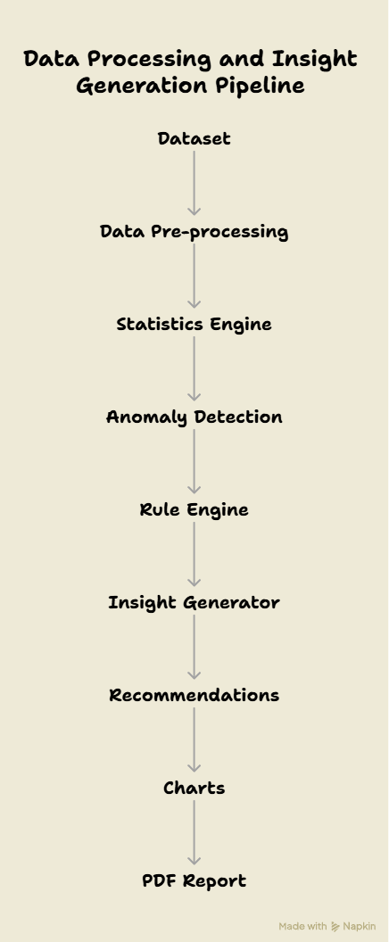
Figure 1.1: AEIA System Workflow Diagram

1.4 Present-Day Scenario and Relevance
Modern maintenance workflows increasingly rely on digital data capture, but the interpretation of that data still requires domain knowledge. The present-day scenario in aviation maintenance is that large sensor streams, condition logs and inspection records are available, yet the decision-making process can still be slowed by manual review. AEIA is relevant because it acts as a bridge between raw engineering data and human-readable maintenance insight.
The project is also relevant because it aligns with the wider shift toward explainable, offline and secure engineering tools. In environments such as aircraft maintenance and defence support, the ability to analyse data locally without exposing it to external servers is a practical advantage.

Module | Purpose
Dataset Import | Reads engineering datasets
Preprocessing | Cleans and validates data
Statistics Engine | Calculates descriptive statistics
Anomaly Detection | Detects abnormal data
Rule Engine | Applies engineering rules
Insight Generator | Generates executive summary
Report Builder | Creates PDF reports
Table 1.1 - Functional Overview of the AEIA System

CHAPTER 2

BACKGROUND THEORY AND LITERATURE REVIEW

2.1 Background Theory
The project combines several established concepts from data analysis and software engineering. Statistical analysis is used to calculate means, variability, trends and correlations. Anomaly detection methods such as Z-score, interquartile range (IQR) and Isolation Forest are used to identify unusual samples. Rule-based reasoning adds engineering logic so that domain-specific safety conditions can be enforced beyond pure statistical significance.
Explainable AI principles are applied throughout the pipeline so that every result can be interpreted by a user. Instead of returning a single opaque score, the system surfaces the exact finding, its source and its relevance. The final text summary is generated using deterministic template-based natural language generation rather than a generative large language model.

2.2 Literature Review
The literature and tool ecosystem around AEIA spans data processing, machine learning, desktop application development and report generation. Pandas and NumPy support efficient tabular processing, scikit-learn provides robust implementations of anomaly detection algorithms, Matplotlib supports charting and ReportLab enables PDF report creation. PyQt5 provides the desktop GUI layer.
In the maintenance domain, predictive maintenance research has shown that combining sensor data, statistical methods and machine learning can improve the early detection of faults. Sequential models are commonly used for degradation trends, while interpretable rules remain essential for real operational decision support. AEIA uses this hybrid philosophy but implements it in a lightweight offline desktop form.
The user interface design also follows established desktop UI principles: clear hierarchy, strong spacing, restrained colour usage and visible workflow stages. This makes the application appropriate for operational environments where readability and speed are more important than decorative styling.

2.3 Summarized Outcome
The survey of tools and methods shows that a practical engineering decision-support system can be built using a hybrid pipeline. Statistical methods discover patterns, machine learning methods expose unusual samples, rule systems enforce operational logic and natural language templates communicate the results to human users in a direct and understandable form.

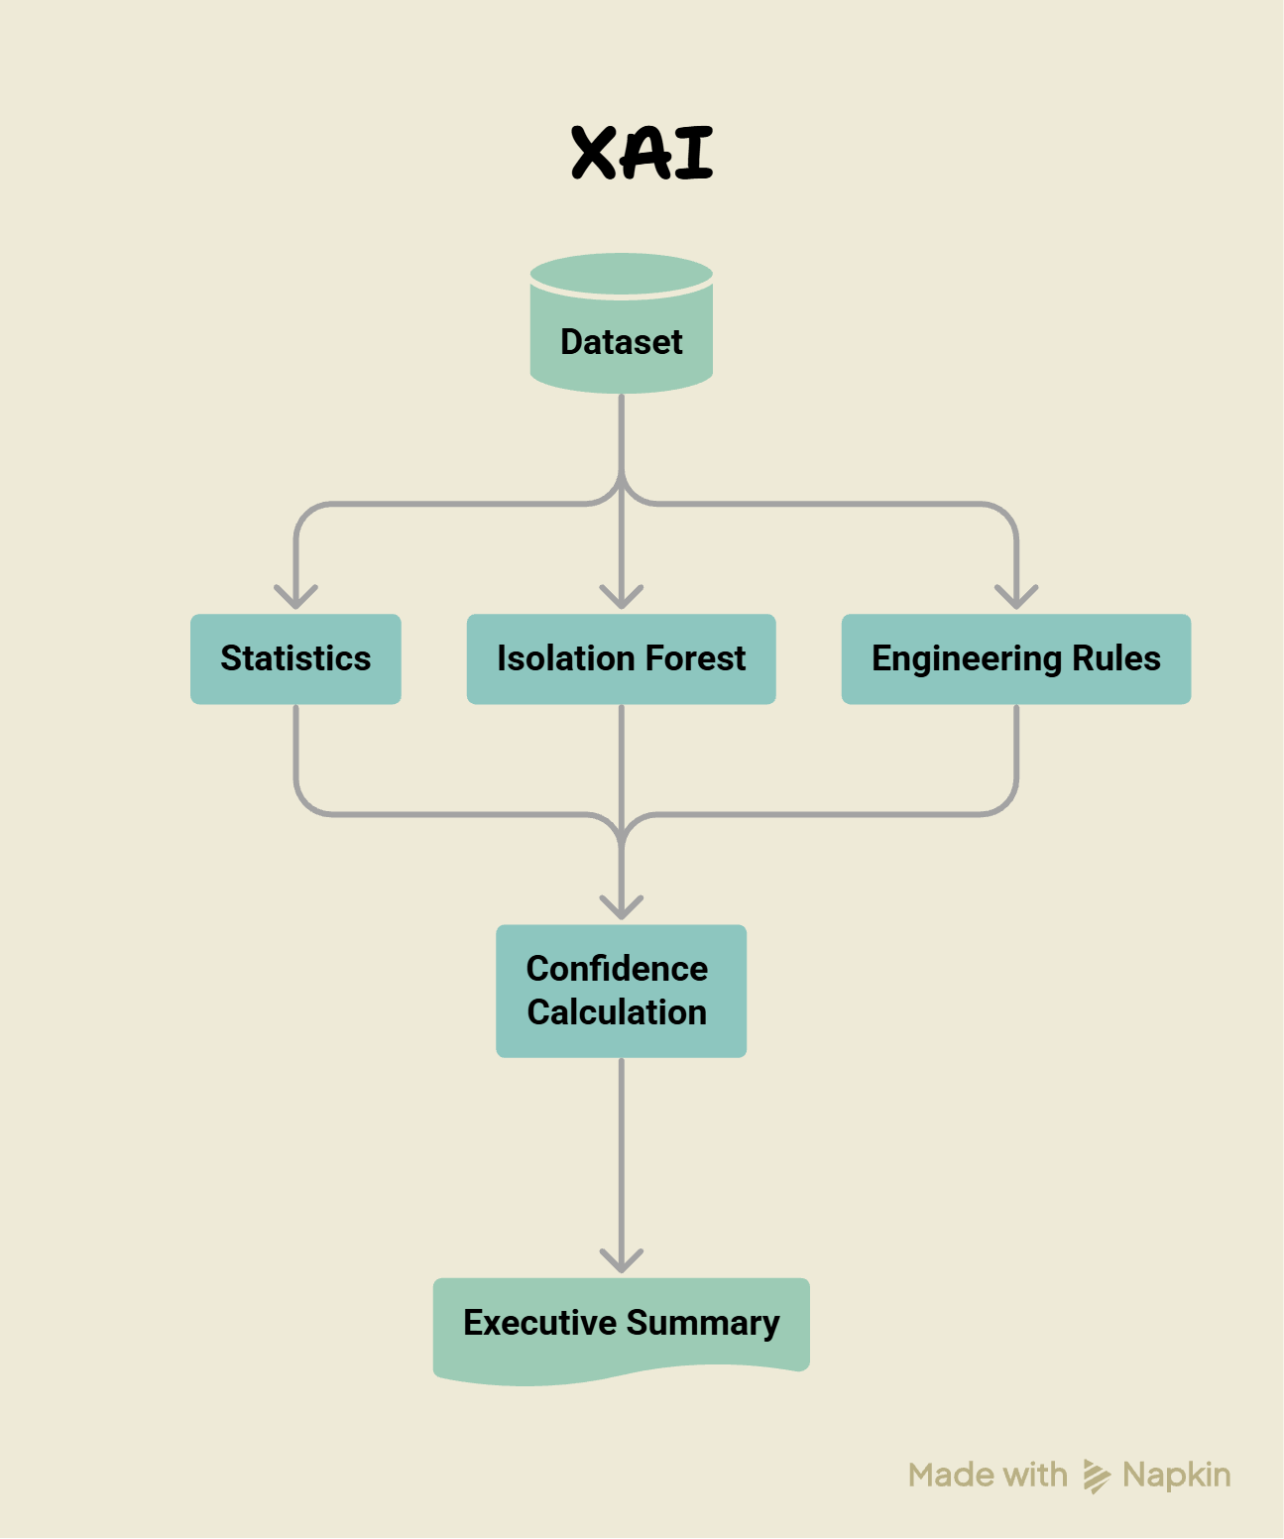
Figure 2.1: Evidence Fusion and Explainability Overview

CHAPTER 3

OBJECTIVE & METHODOLOGY

3.1 Methodology
The AEIA methodology follows a fixed sequence. First, a dataset is imported from a local file. The preprocessing module cleans the data by removing duplicates, handling missing values and normalizing formats. Next, the statistics engine calculates descriptive metrics and trend behaviour. The anomaly detector identifies unusual points using Z-score, IQR and Isolation Forest. The expert system evaluates engineering rules. Finally, the insight generator converts the structured findings into human-readable text, the recommendation engine produces prioritized actions and the report builder assembles the final PDF output.
This pipeline is intentionally modular so that each stage remains independent and explainable. The GUI communicates the results through panels, tabs, cards and tables, while the database stores imported sessions, findings and history.

3.2 Component Specifications and Tools Used
• Language: Python
• GUI framework: PyQt5
• Data handling: pandas and NumPy
• Machine learning: scikit-learn
• Charting: Matplotlib
• PDF generation: ReportLab
• Database: SQLite
• Text processing: NLTK / spaCy for language refinement
• Deployment: PyInstaller single executable for offline use
The key component-selection justification was portability. All tools were chosen so the complete solution can run on a workstation without requiring external services or a web browser. This is important for secure or air-gapped engineering environments. The design also avoids GPU dependence and keeps the computational load suitable for CPU-only systems.
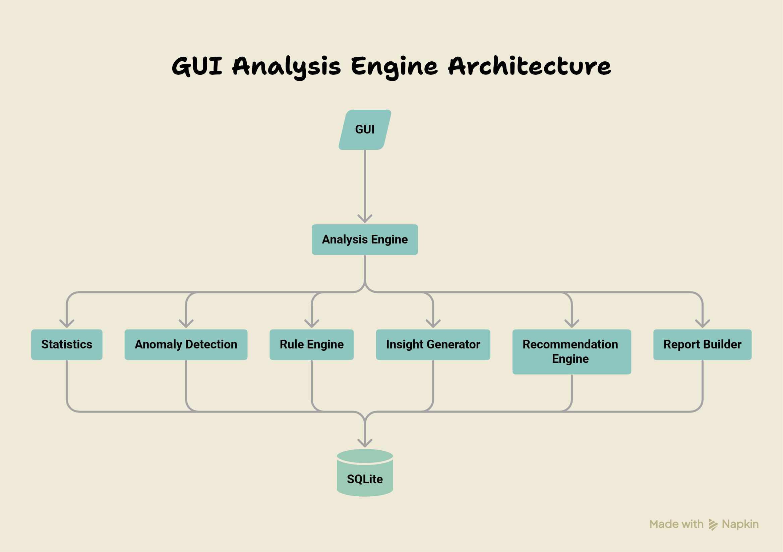
Figure 3.1: Overall Software Architecture of AEIA
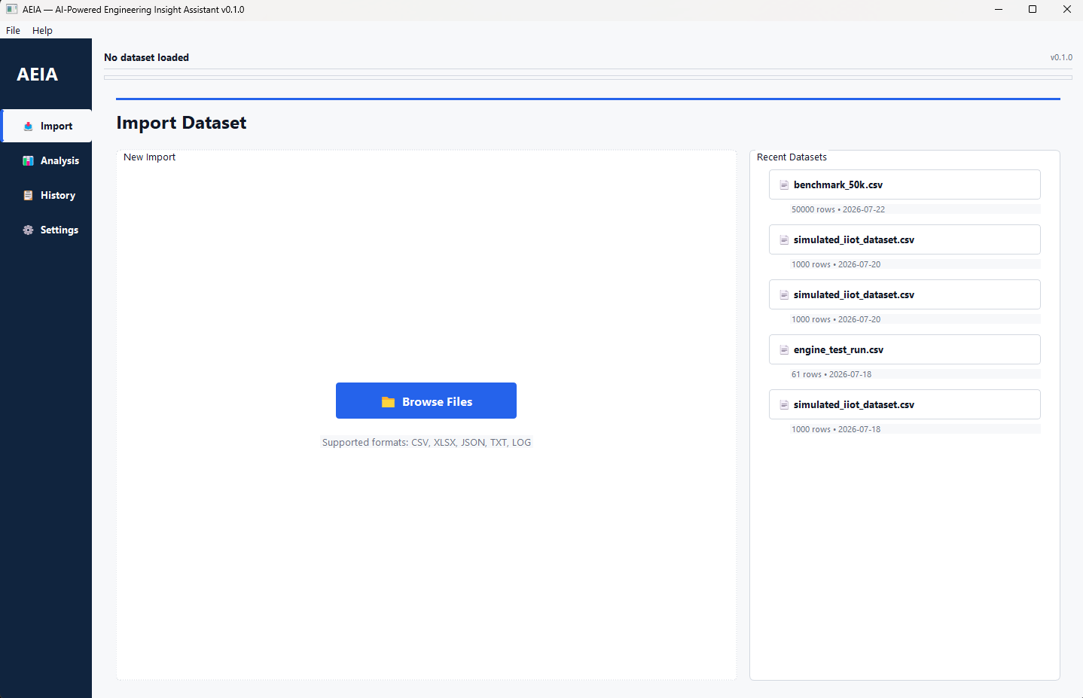
Figure 3.2: AEIA Main User Interface

CHAPTER 4

RESULT ANALYSIS

4.1 Analysis Output and Observations
The completed AEIA system produces a structured report containing a statistical summary, engineering findings, recommendations, charts and a natural-language executive summary. The report makes it easier for an engineer to identify the most important issue first and then drill down into the supporting evidence.
In the validated sample datasets used during development, the system successfully identified critical threshold breaches, warning-level anomalies, multivariate abnormal patterns and stable operating conditions. The report output was refined so that the executive summary reads like an engineering report instead of a raw statistical dump.
The final UI also supports interactive review of findings, history browsing and report export. This allows the user to move from analysis to interpretation without leaving the application.
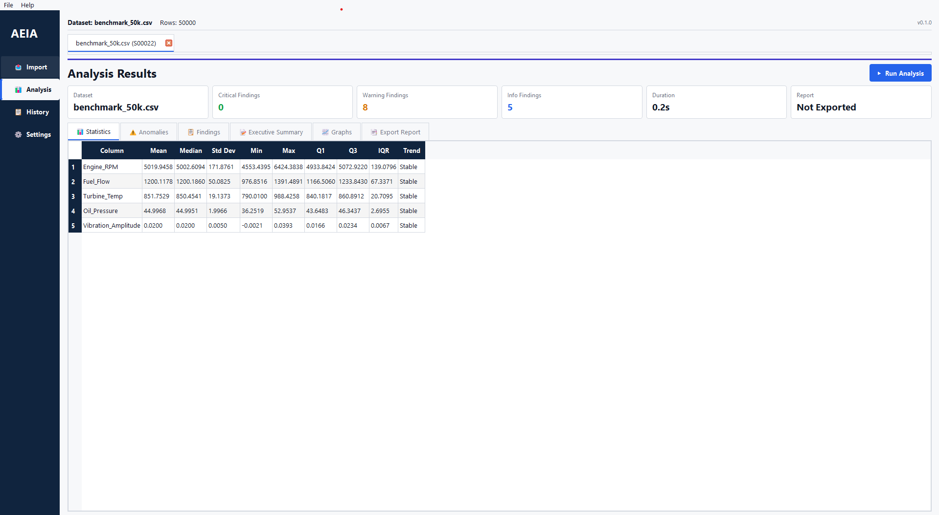
Figure 4.1: Analysis Dashboard Screenshot
The dashboard presents the detected findings together with their severity levels. The system classifies engineering observations into categories so that maintenance personnel can quickly identify the urgency of each issue and decide the appropriate corrective action.

Severity | Typical Observation | Recommended Action
Critical | Multiple anomalies or engineering rule violations | Immediate inspection
Warning | Moderate abnormal behaviour | Schedule maintenance
Normal | Parameters within limits | Continue monitoring
Information | Informational observations | No action required
Table 4.1 – Example Findings by Severity

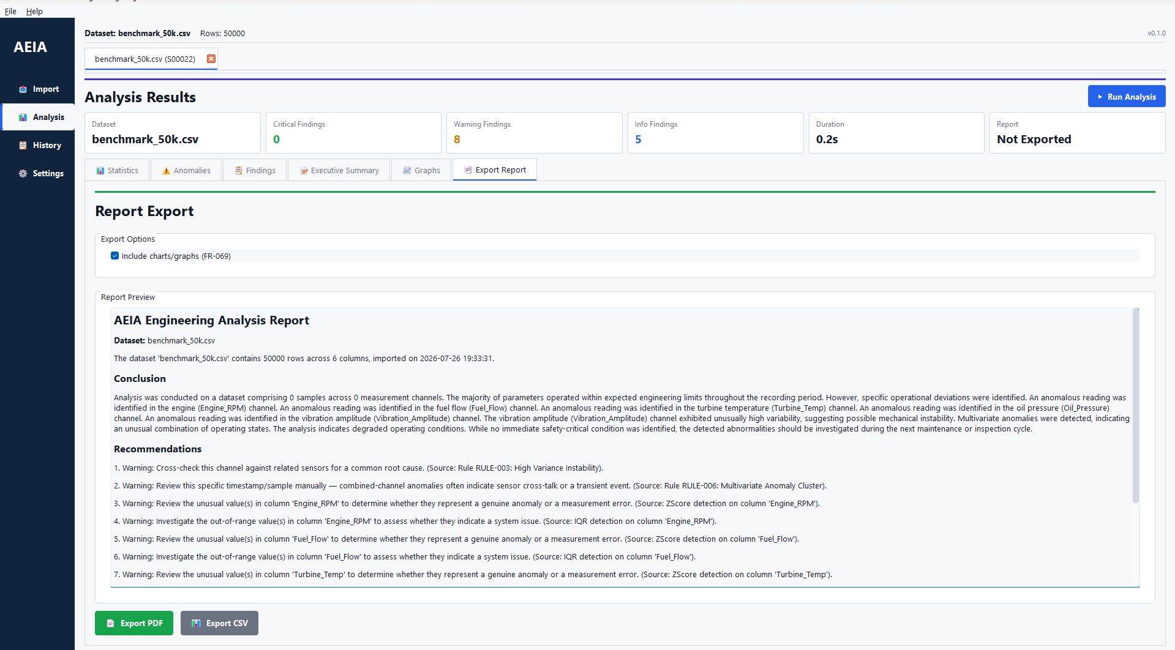
Figure 4.2: Executive Summary and Findings Screenshot

4.2 Performance and Validation Summary
During testing, the pipeline was calibrated to reduce false positives on clean data while still preserving critical detections on failure data. The performance optimizations introduced during Phase 5 improved responsiveness on low-end workstations by reducing repeated calculations, downcasting numeric data where safe and delaying chart generation until it is needed.

Optimization | Purpose | Benefit
Numeric downcasting | Reduce memory usage | Lower RAM consumption on low-end systems
Cached intermediate results | Avoid repeated calculations | Faster analysis execution
Delayed chart generation | Generate charts only when required | Improves responsiveness for large datasets
Modular processing pipeline | Independent execution of analysis stages | Easier maintenance and better explainability
Offline executable packaging | Deploy using PyInstaller | Runs without Python installation or internet
SQLite local storage | Store analysis history locally | Secure offline data management
Table 4.2 – Performance Optimization Summary
The final build was also packaged as a standalone Windows executable suitable for transfer via USB to offline engineering systems. This confirmed that the software can be deployed in the intended HAL environment without requiring internet access or a separate Python installation.

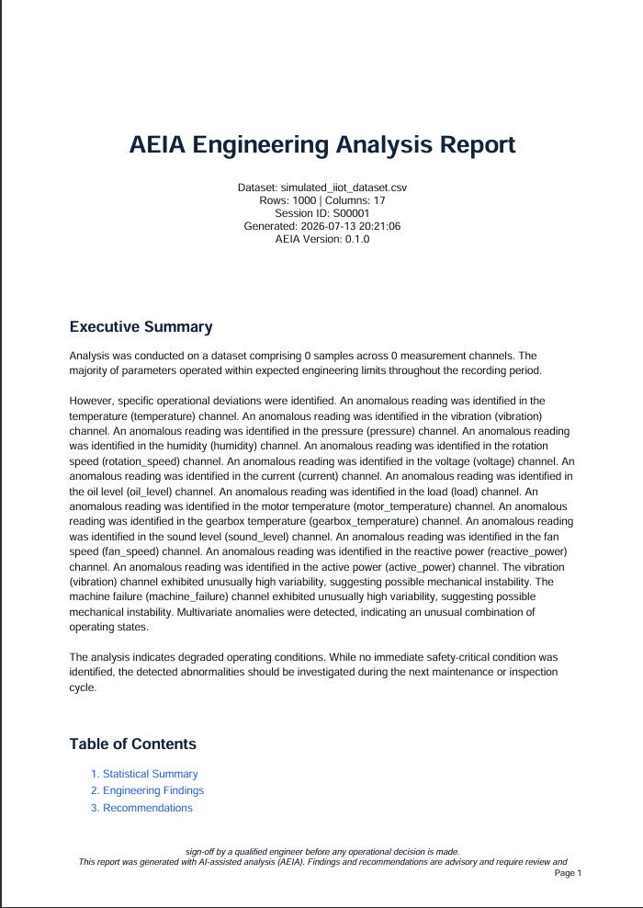
Figure 4.3: Sample PDF Report Screenshot

CHAPTER 5

CONCLUSION AND FUTURE SCOPE

5.1 Work Conclusion
AEIA demonstrates that a practical engineering insight assistant can be built with an offline, explainable and deterministic architecture. The system combines preprocessing, statistics, anomaly detection, rule evaluation, narrative generation, reporting and a modern desktop GUI into a single workflow that is suitable for maintenance support tasks.
The project meets its main objective of helping engineers interpret structured data more quickly and with better traceability. It is especially valuable in environments where internet access is limited and where users need clear, defensible outputs rather than opaque AI results.

5.2 Future Scope of Work
• Support additional engineering domains through reusable rule packs.
• Add more input formats and richer metadata mapping.
• Improve interactive visualization of findings and charts.
• Add role-based user support if the deployment scope expands.
• Expand benchmarking across larger datasets and different workstation classes.
Future enhancements should preserve the core principles of the current system: offline operation, explainability, deterministic results and a lightweight desktop footprint.

REFERENCES
[1] F. T. Liu, K. M. Ting, and Z.-H. Zhou, “Isolation Forest,” Proceedings of the 2008 IEEE International Conference on Data Mining, 2008.
[2] W. McKinney, “Data Structures for Statistical Computing in Python,” Proceedings of the 9th Python in Science Conference, 2010.
[3] J. D. Hunter, “Matplotlib: A 2D Graphics Environment,” Computing in Science & Engineering, vol. 9, no. 3, 2007.
[4] F. Pedregosa et al., “Scikit-learn: Machine Learning in Python,” Journal of Machine Learning Research, vol. 12, 2011.
[5] ReportLab Technologies, “ReportLab User Guide,” official documentation.
[6] Riverbank Computing, “PyQt5 Reference Guide,” official documentation.
[7] Bird, Klein and Loper, “Natural Language Processing with Python,” O’Reilly Media.

ANNEXURES

Annexure A: Complete System Architecture
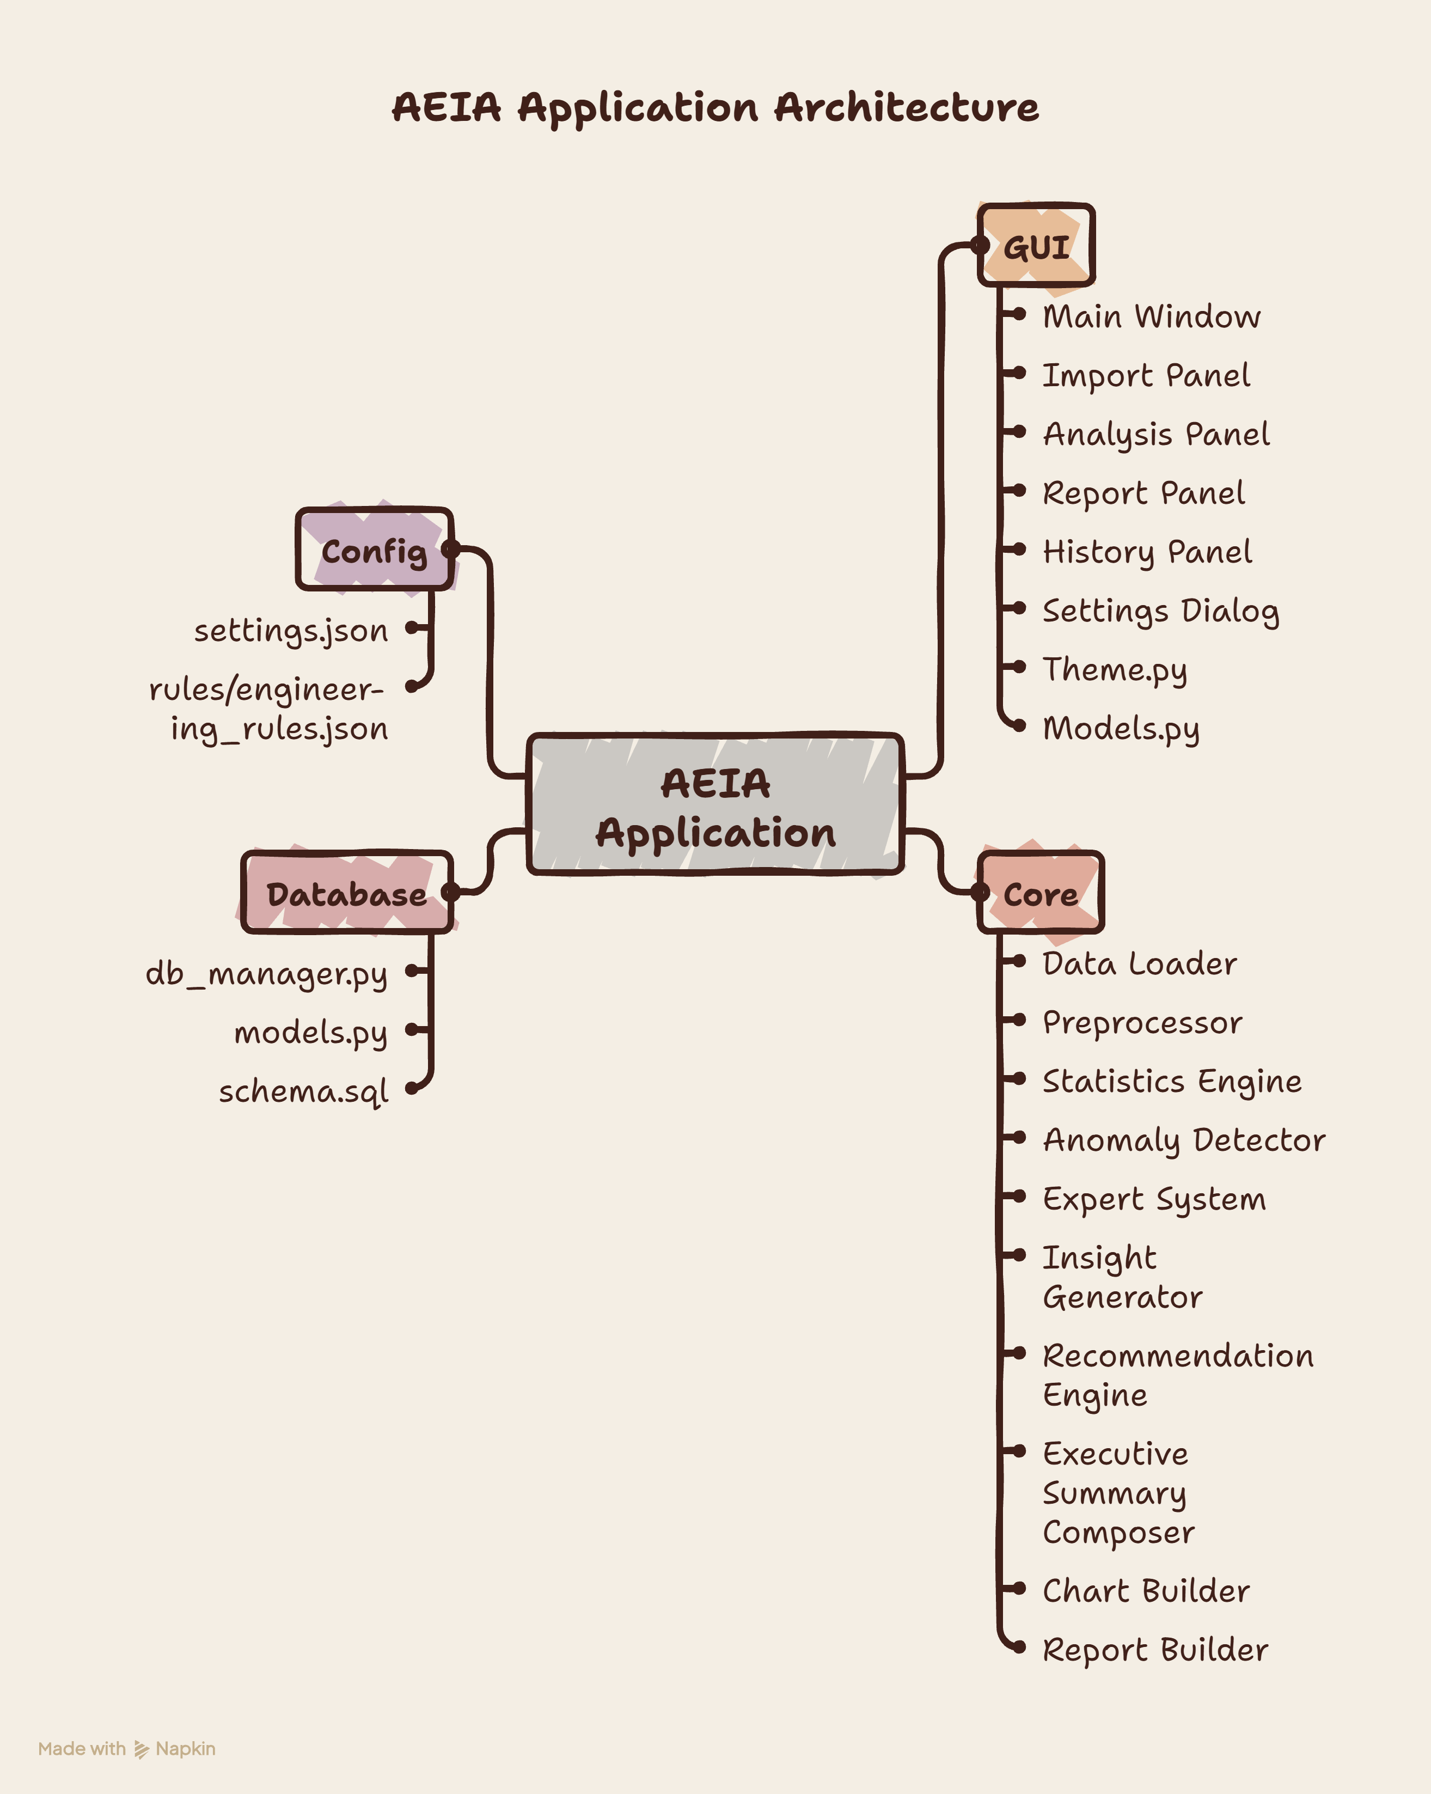
Table A.1 - Complete System Architecture

ANNEXURE B: Addition GUI Screenshots
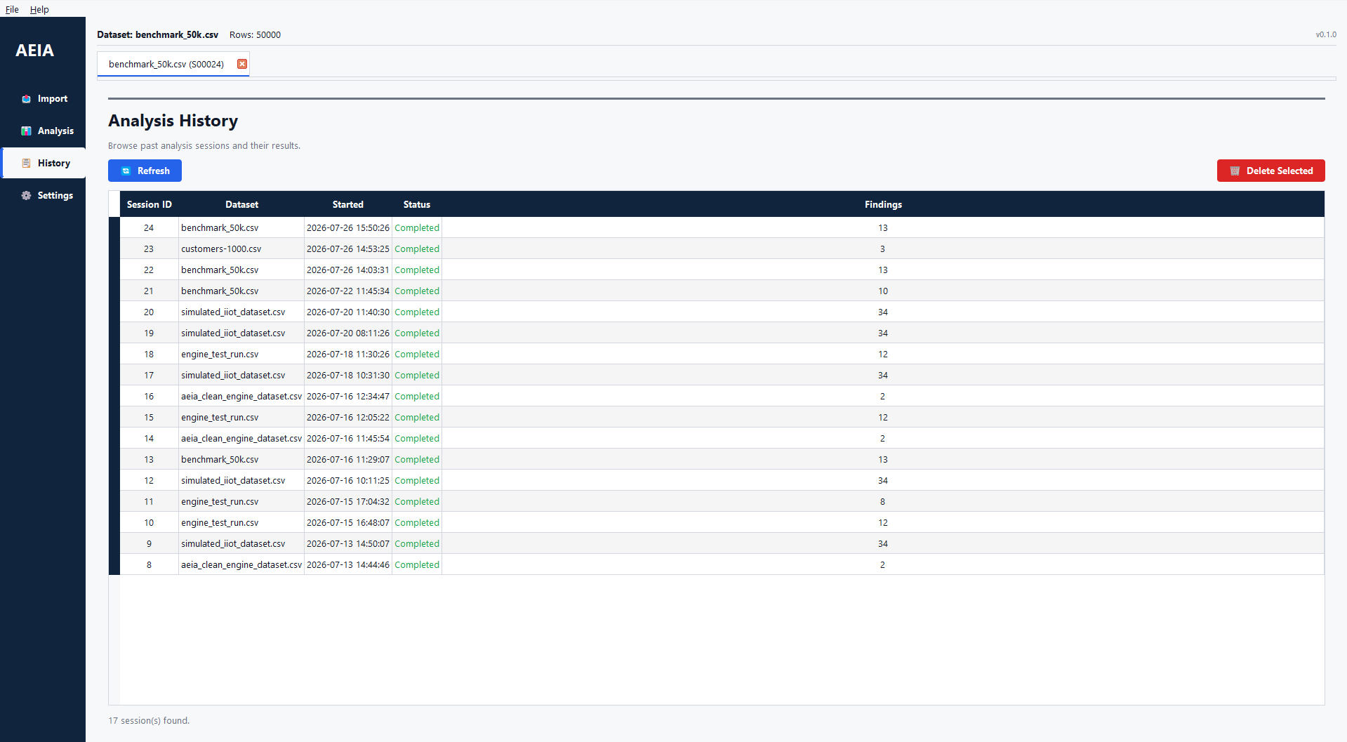
Figure B.1 – History Page
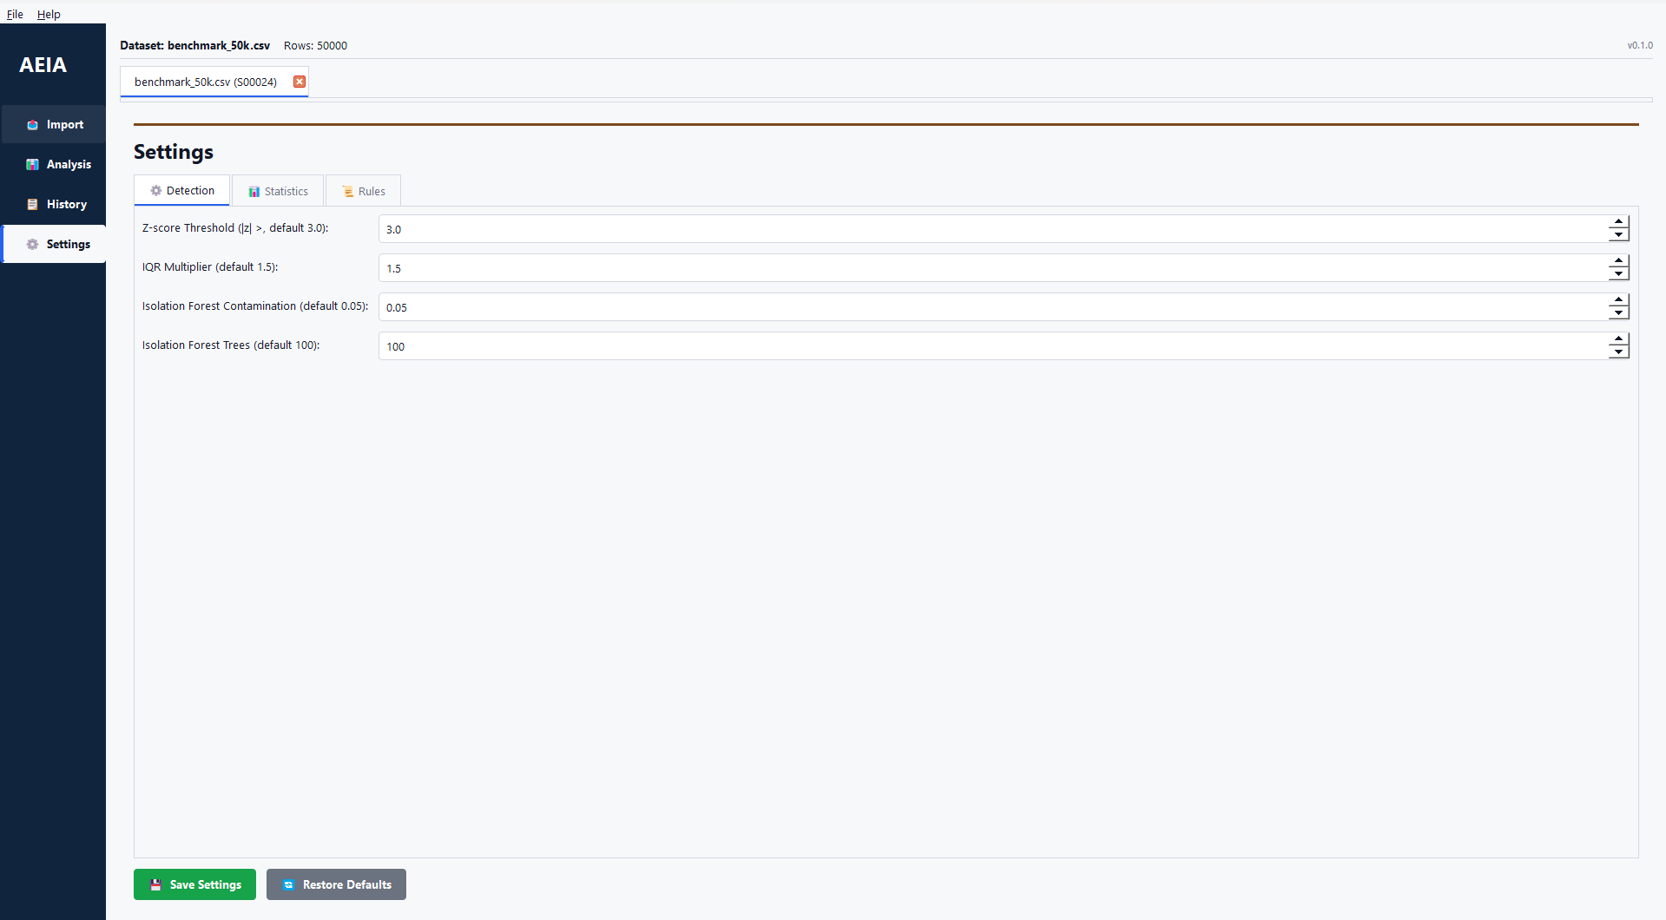
Figure B.2 – Setting Page

